<https://www.youtube.com/watch?v=xV2Ujx0iUlw>

1. Click File->New-> Graphql will load the below screen:

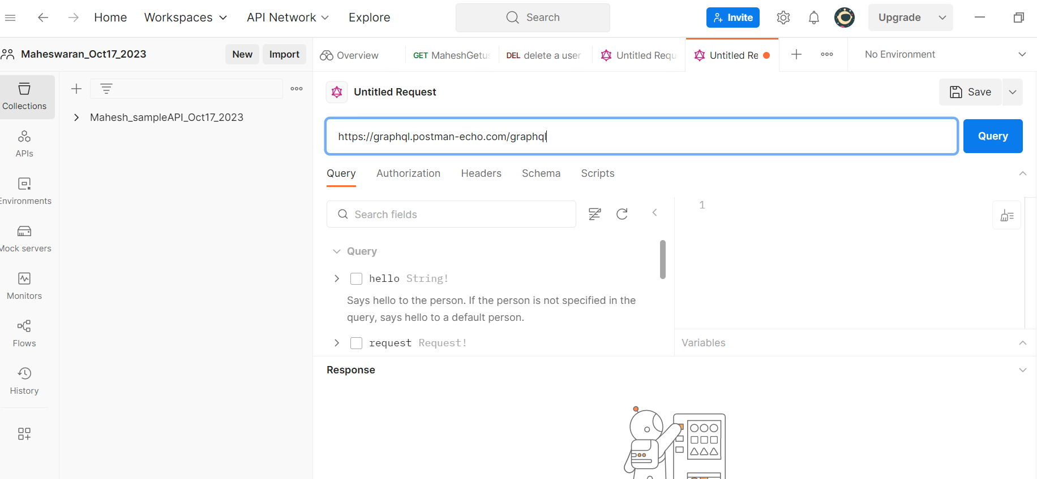

1. Use this url for graphql request: <https://graphql.postman-echo.com/graphql>

Select hello and we will get the below response:

